**Personal information:**

***Name*:** Hafsa Mohammed Yousif

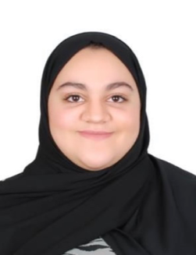***Date of Birth***: 11/10/1998

***Gender***: Female

***Marital status***: Single

***Nationality***: Bahraini  
***phone number***: 33640145

***Email address***: hafsamohd98@gmail.com

**Objective:**

Seek to work in an environment that will challenge me further; while allowing me to contribute to the continued growth and success of the organization.

**Educational background:**

***2005 – 2011***: Um Ayman Primary School

***2012 – 2013***: Um Salama & Alhidd Intermediate School

***2013 – 2017***: Hamad Town Secondary Girls School

**Languages Known:**

* English – written, spoken & read (Excellent)
* Arabic – written, spoken & read (Excellent )

**Skills:**

* Hard under pressure
* Customer service
* Team worker
* Computer Skills
* Always eager to learn.

**Job Experiences:**

Worked as a trainee at “Hamad Town Municipality”.

worked as a saleswoman in a perfume shop.

Worked as a salewomen in alsoror clothes shop.

Worked in alharam Real state :

- Selling and buying properties and gaining customers trust

- Communication between the seller and the buyer .

- Commercial transactions clearance.

**Declaration**:

I hereby certify that the above information is true and correct to the best of my knowledge.